RPS Database
RPS aggregates data from across various sources, including:
- Data collected through our Brookfield real estate operating platform, which includes RPS Real Property Solutions Canada’s second largest appraisal management firm and Royal LePage Canada’s second largest real estate franchise.
  - RPS Real Property Solutions coordinates ~ 180k appraisals a year. These appraisals are preformed on behalf of Canada’s largest banking institutions in support of the unwriting of mortgages. Appraisal reports provide rich details on the subject property being evaluated including the following broad sections.
    - Property and purpose of Appraisal
    - Neighborhood descriptions
    - Site description
    - Improvements (building) exterior details
    - Improvements (building) interior details
    - Building room allocation
    - Cost Approach for valuation based on improvements and depreciation
    - Sales comparison approach for valuation
    - Building and comparable photos.
The true value in is the sales comparable approach where the appraiser lists the details on three or more recently sold MLS properties as comparable sales that took place in close geographic proximity and with a recent time frame of the property being appraised.
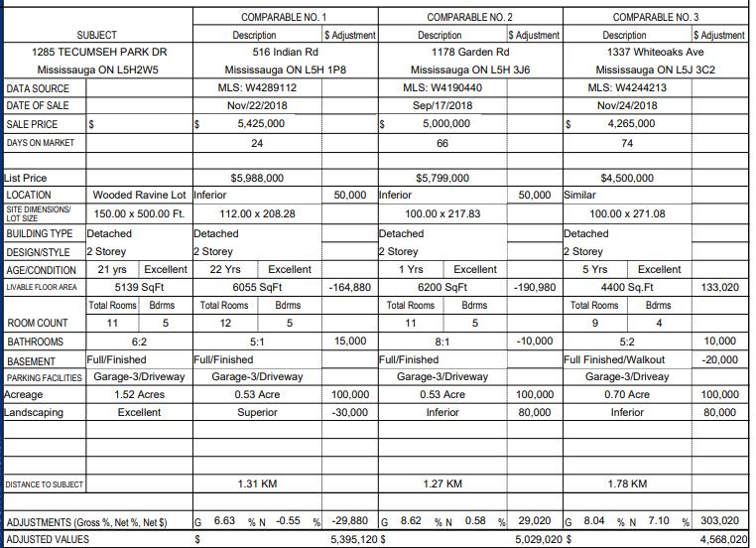
The reports preformed by the RPS appraiser network are completed using our form technology and allows us to store all the data entered in machine readable format. (XML). Internally RPS extracts the XML data and transforms it into a structured database. Additional functions are applied in the process including geocoding, and standardizing.
  - Royal LePage is a real estate franchisor, unfortunately being a franchisor does not provide unrestrictive access to the MLS system in Canada. This is generally only available to the Brokerages (franchisees). That said as part of the back-office requirements the franchisees mode provide the franchisor an understanding of the deals flowing through. From the back-office systems RPS is provided with address, date and sold price information on transactions that have occurred.
- Data Cleaning and Standardization
The unification of two sources of data ultimately leads to RPS seeing the same transaction multiple times. As such, RPS undergo an exercise each month to reconcile the best transactions to leverage in our data products. Once the reconciliation occurs the RLP data represent 15% of transactions and RPS data represent 85% of the transactions.
To understand what proportion of all transactions the combined dataset represents we need to compare to transaction counts from CREA. CREA is not always forthcoming with transactions counts however we do have some 10 year average number by province. The numbers below represent our 2018 September counts compared to the CREA 10 year average of September.
Generally, RPS have a 75 – 80% pen rate which allow us to be representative in data products we create.
For residential real estate valuation and price trend products, RPS uses only in-market, resale transaction values and does not use appraised values.
RPS has the right to use this data through our relationships and agreements. Privacy rights are protected and not infringed because the data is used in an aggregate and anonymous fashion. No personally identifiable information (PII) is provided in our end products.

RPS’ housing database provides a consolidated source of Canadian real estate information, property data, market trends, and advanced analytics. It aggregates inputs to provide rich features including:
- Coast-to-coast coverage in both urban and rural areas
- 8 million transactions, including 5+ million properties across Canada
- Continuously refreshed and populated, amounting to hundreds of thousands of records being added on an annual basis
- Historical coverage from 2004 to present, updated every month
- Standardized, geocoded and aggregated data for optimal use

